11. To classify credit scores using the Decision Tree algorithm.
Procedure
- Import the Decision Tree Classifier.
- Create the dataset and class labels.
- Train the model using the training data.
- Predict the credit score category.
- Display the predicted result.
Dataset 1: Customer Loan Profile
Annual Income (₹ Lakhs) | Credit History (Years) | Existing Loans | EMI Paid on Time | Credit Score
12 | 10 | 1 | Yes | Excellent
10 | 8 | 2 | Yes | Good
8 | 6 | 2 | Yes | Good
6 | 4 | 3 | No | Average
4 | 2 | 4 | No | Poor
15 | 12 | 1 | Yes | Excellent
7 | 5 | 3 | Yes | Average
5 | 3 | 4 | No | Poor
11 | 9 | 2 | Yes | Good
3 | 1 | 5 | No | Poor
Target Variable
Credit Score: Excellent, Good, Average, Poor
Code and output:
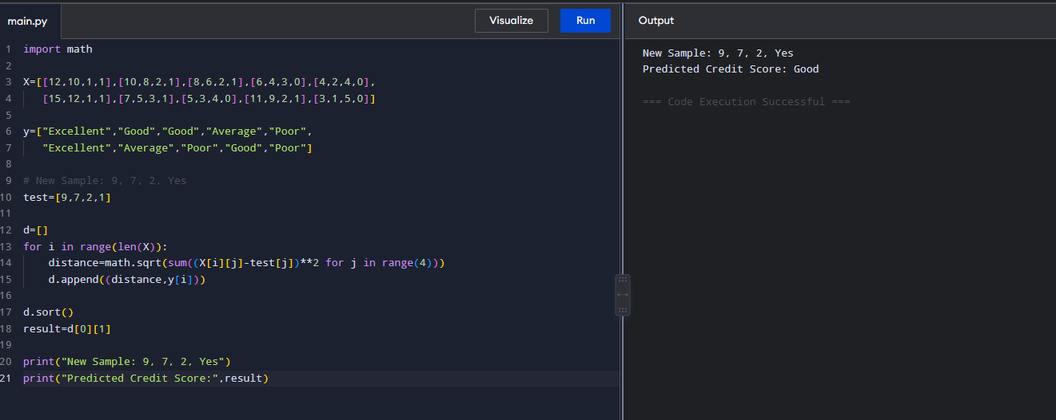

Dataset 2: Bank Customer Credit Rating
Monthly Income (₹) | Age | Loan Amount (₹ Lakhs) | Loan Default | Credit Score
90000 | 45 | 5 | No | Excellent
75000 | 40 | 6 | No | Good
60000 | 35 | 8 | No | Good
45000 | 30 | 10 | Yes | Average
30000 | 25 | 12 | Yes | Poor
95000 | 48 | 4 | No | Excellent
65000 | 37 | 7 | No | Good
40000 | 28 | 9 | Yes | Average
28000 | 24 | 13 | Yes | Poor
85000 | 43 | 5 | No | Excellent
Target Variable
Code and output:
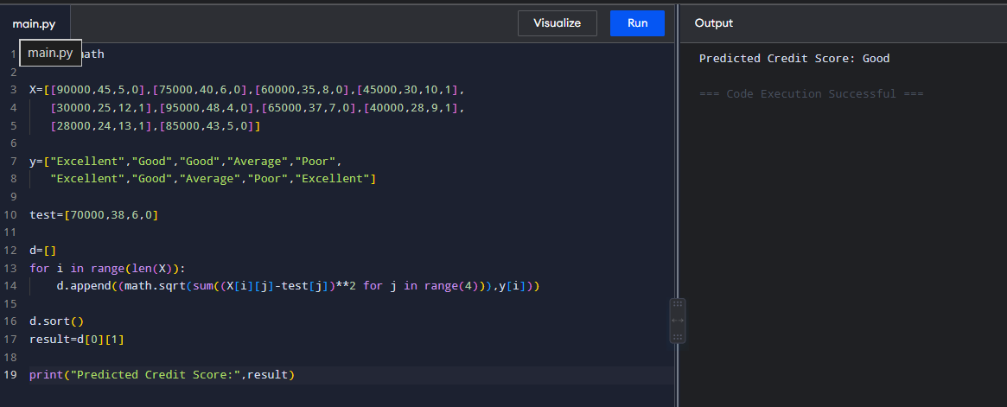

Dataset 3: Credit Card Customer Analysis
Credit Limit (₹ Lakhs) | Monthly Spending (₹) | Payment Delay (Days) | Credit Score
8 | 40000 | 0 | Excellent
7 | 35000 | 2 | Good
6 | 30000 | 4 | Good
5 | 25000 | 10 | Average
4 | 20000 | 20 | Poor
9 | 45000 | 0 | Excellent
6 | 28000 | 5 | Good
5 | 23000 | 12 | Average
3 | 18000 | 25 | Poor
8 | 42000 | 1 | Excellent
Code and output:

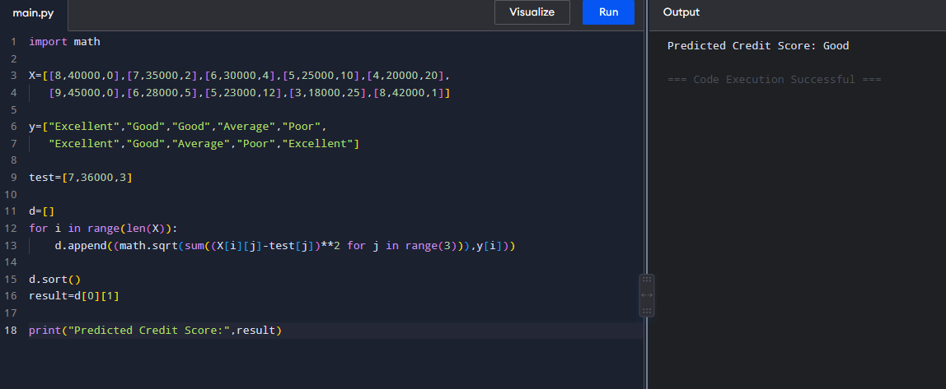
Dataset 4: Personal Finance Profile
Savings (₹ Lakhs) | Monthly Expenses (₹) | Outstanding Debt (₹ Lakhs) | Credit Score
10 | 30000 | 1 | Excellent
8 | 35000 | 2 | Good
6 | 40000 | 3 | Good
4 | 45000 | 5 | Average
2 | 50000 | 7 | Poor
11 | 28000 | 1 | Excellent
7 | 36000 | 2 | Good
5 | 43000 | 4 | Average
3 | 48000 | 6 | Poor
9 | 32000 | 1 | Excellent
Code and output:
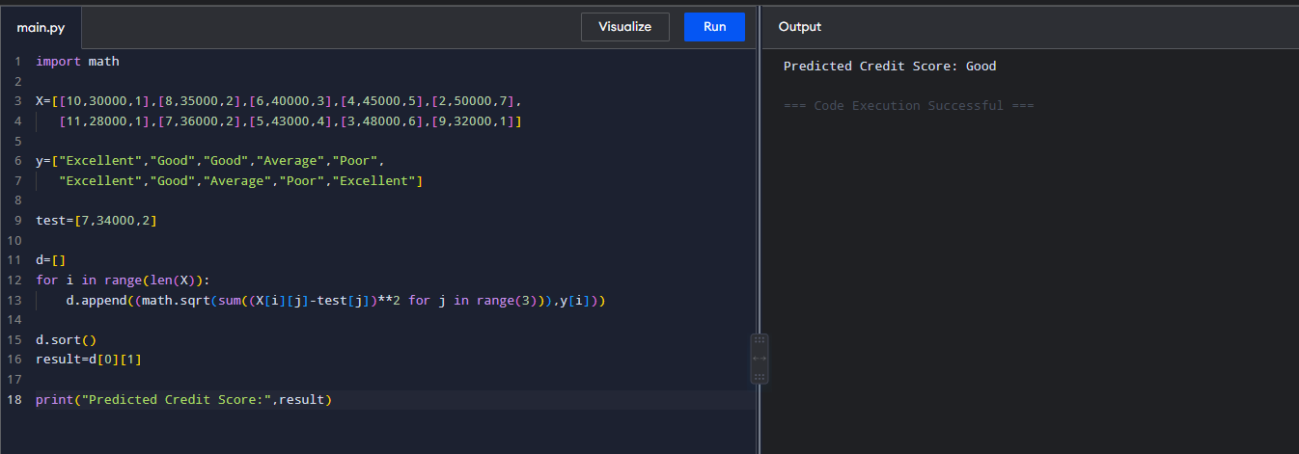
Dataset 5: Home Loan Eligibility
Salary (₹ Lakhs) | CIBIL Score | Existing EMIs | Loan Status | Credit Score
15 | 850 | 1 | Approved | Excellent
12 | 800 | 2 | Approved | Good
10 | 760 | 2 | Approved | Good
8 | 700 | 3 | Pending | Average
6 | 620 | 4 | Rejected | Poor
16 | 880 | 1 | Approved | Excellent
11 | 780 | 2 | Approved | Good
7 | 680 | 3 | Pending | Average
5 | 600 | 5 | Rejected | Poor
14 | 830 | 1 | Approved | Excellent

Code and output:
